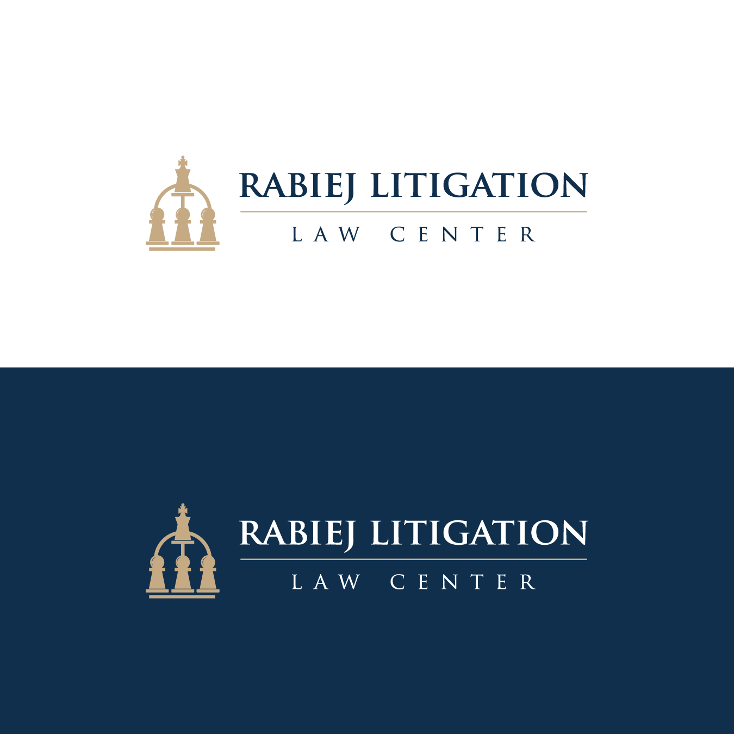

2023 Report on Center Activities
The Center is pleased to provide this summary report on its first full year of operations. It was an exciting and productive year.
The Center held three highly successful bench-bar conferences, developed guidelines and best practices drafted by teams of judges, lawyers, and other experts addressing seven cutting-edge issues affecting mass-tort MDLs, class actions, and ediscovery, and produced independent research. More than 40 federal judges and 200 lawyers and other experts attended the three conferences. More than 70 judges, lawyers, and other experts served on nine teams drafting guidelines and best practices, which ultimately will be incorporated into the Center’s Complex Litigation Compendium of Guidelines and Best Practices.
Bench-Bar Conferences
- “Ediscovery at a Crossroads” Conference at George Washington University School of Law (April 13-14, 2023)
- “Review of Class-Action Developments” held virtually (July 20-21, 2023)
- “MDL Bench-Bar Leadership Conference” at Northwestern University School of Law (September 28-29, 2023)
Information about these conferences remains on the Center’s website under “Past Events,” including agenda, panelists, attendees, and materials, which may be particularly helpful to those applying late for CLE credit.
Guidelines and Best Practices
- MDL Initial-Management Conference (Fed. R. Civ. P. 16.1) (public-comment publication expected in summer of 2024)
- MDL Maturity Criteria (public-comment publication expected in early 2024)
- Optimum Proportionality eDiscovery Standard (public-comment publication expected in early 2024)
- Mass-Tort MDL-Bankruptcies Judicial Estimation (public-comment publication expected in early 2024)
- Class-Action Notice Incorporating Changing Online and Platform Technologies (public-comment publication expected in December 2023)
- Maintaining Ediscovery New Framework (ongoing)
- Staying Actions Pending JPML Orders (public-comment publication expected in December 2023)
Research
- Excel spreadsheet of durations of large mass-tort and antitrust MDLs
- Caselaw referencing marginal-utility test in ediscovery
Bench-Bar Leadership Conferences Planned for 2024
- Ediscovery Conference (Optimum Proportionality Ediscovery Standard – OPES) Virtual (March 28, 2024)
- Protracted MDLs Conference at Cleveland State University School of Law (June 13-14, 2024)
- Ken Feinberg Workshop on Examination of MDL Filings and Vetting Procedures at Northwestern University School of Law (August 8-9, 2024)
- Mass-Tort Bankruptcies at George Washington School of Law (November 14-15, 2024)
The Center is grateful for the support and help from its Advisory Councils of Judges, Lawyers, and Other Experts as well as it sponsors and patrons, which are essential.
The Center’s website is regularly updated at rabiejcenter.org. All comments and suggestions are welcome at contact@rabiejcenter.org.
The Center’s mission is to bring the bench and bar together to address timely litigation issues arising in ediscovery matters, class actions, and mass-tort MDLs.

