
February 4, 2024
ROOT CAUSE OF THE EDISCOVERY PROBLEM
Ediscovery practice is moving inexorably toward identifying all possibly relevant information on all possibly relevant data sources. The day is quickly coming when the universe of data subject to a broad initial litigation-hold can be searched by artificial-intelligence advanced algorithms. Such “recall” may be attainable, but it also sweeps in massive unimportant information. Both sides lose when ediscovery produces millions of inconsequential pages.
The root cause of this predilection for higher and higher recall rates is that lawyers on opposing sides, and even on the same side, will always disagree in good faith on which documents are relevant. Because a requesting party cannot rely on existing validation processes, they seek discovery of as many documents as the court permits so that they can verify for themselves which documents are important in resolving the issues. Rule 26 proportionality limitations offer reasonable guard rails, but implementation is not practical.
The pyramid below illustrates the inverse relation between “recall” and “precision.” In 2011, Microsoft submitted a diagram to the Advisory Committee on Civil Rules illustrating the average number of pages preserved, collected, processed, reviewed, produced, and used at trial in its cases. The diagram below lays out the stages in narrowing 48 million potentially relevant pages to 142 pages used at trial. At each stage, Microsoft made judgments classifying documents as relevant or not relevant.

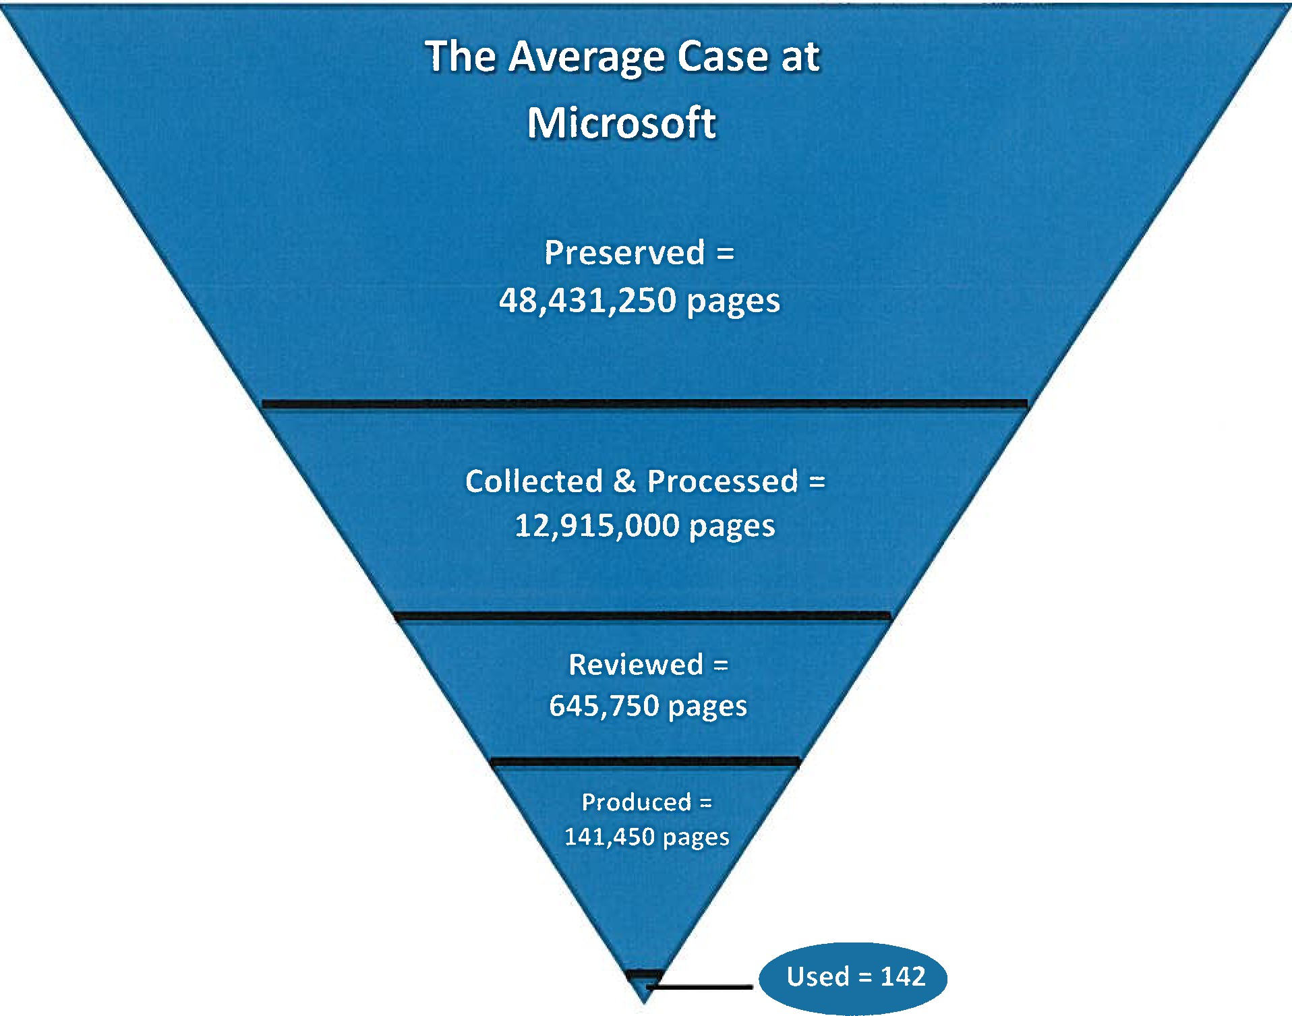
EXISTING PRACTICES AND PROCEDURES
Under existing practices and procedures, ediscovery produced 141,450 pages that Microsoft deemed non-privileged and relevant. But because the parties will disagree with Microsoft’s relevancy classifications, the plaintiff will justifiably argue for disclosure not only of the 141,450 pages, but also the 645,750 “reviewed” pages to decide for itself whether documents important in resolving the issues were omitted. And because “relevant” information is broadly defined and the fact that Microsoft suspected that 13 million pages might be relevant and that a total of 49 million pages conceivably might be relevant, the plaintiff may also want to check an unknown number of these added documents subject to proportionality considerations.
The existing system incentivizes: (1) plaintiffs to get as many of the 49 million pages as needed to eliminate doubts so that they can decide for themselves whether any documents important in resolving the issues were omitted; (2) defendants to litigate requests for additional discovery on grounds of cost and burdens, which are decided on subjective proportionality grounds with little predictability on motions to compel; and (3) courts to pressure the defendants to allow plaintiffs to get more involved in the defendant’s conducting of ediscovery, so that plaintiffs can verify the defendant’s relevancy classifications and reduce the number of disputes reaching the court.
OPTIMUM PROPORTIONALITY EDISCOVERY STANDARD (OPES)
OPES recognizes that plaintiffs and courts will not accept at face value the defendant’s relevancy classifications that it makes at every stage and, as a result, that plaintiffs justifiably will want to review as many of the 49 million pages as possible to decide for themselves whether key pages were omitted. The key pages would include not only the 142 pages used at trial but an unknown number of pages (e.g., 10,000 pages for purposes of discussion), which may be necessary to understand the 142 pages in resolving the issues.
The bench and bar in three major mass-tort MDLs as well as the Department of Justice Antitrust Division and the Federal Trade Commission recognize that existing ediscovery practices are not sustainable because of the volume. Each has run a validation process that discloses all documents drawn from random samples of nonresponsive documents to assure the other side that documents that they deem to be important in resolving the issues have been produced. OPES focuses on enhancing the validation process to assure that important documents have been identified in the ediscovery, minimizing the need to independently review all potentially responsive documents.
Both sides win when ediscovery produces documents that each side determines to be important in resolving the issues with precision. Courts also win because instead of being asked to guess about the possible existence of potentially relevant documents located on possibly relevant data sources, judges will rule on a limited number of disputed individual documents.
Under OPES, the defendant does not produce inconsequential documents that are not important in resolving the issues. And in many large cases, this could mean tens of thousands, if not hundreds of thousands, of inconsequential documents. But to ensure that no document that the plaintiff deems to be important in resolving the issues is omitted, a “simple random sample” (process of selecting a sample in a random way) of the documents that the defendant deems not responsive is taken.
More is required because unless all the nonresponsive documents in this random sample are also disclosed for the plaintiff to make their own assessment, the root cause of the ediscovery problem will remain. But disclosing nonresponsive documents in the random sample to the plaintiff raises legitimate concerns about revealing information that could lead to prosecution of new unrelated claims or suggest new grounds in the instant case. Under OPES, a defendant is entitled to withhold any nonresponsive documents from the random sample, subject to a judicial in camera examination, evaluating whether the documents are important in resolving the issues.
Under OPES, the plaintiff is better informed about whether documents important in resolving the issues were omitted because they either examine the documents that the defendant deems to be non-responsive in the random sampling or a judge reviews them in an in camera examination. At the same time, the entire process is improved because judges rule on disputed documents found in the random sampling, which informs the parties about what the court deems to be important in resolving the issues.
Further study may identify other means to strengthen the results of the “simple random sampling,” including “diversity algorithms” driven by “relative entropy” assessments as well as other new information-science techniques. Nonetheless, no matter which validation process is used, the parties or the court will have to decide for themselves an acceptable number and materiality of documents important in resolving the issues that inevitably will be omitted and identified in the random sampling, but perfection has never been required.
The stronger the validation process, the greater the confidence in moving from increasing “recall” rates to improving “precision” -- a win for both sides and the courts.

