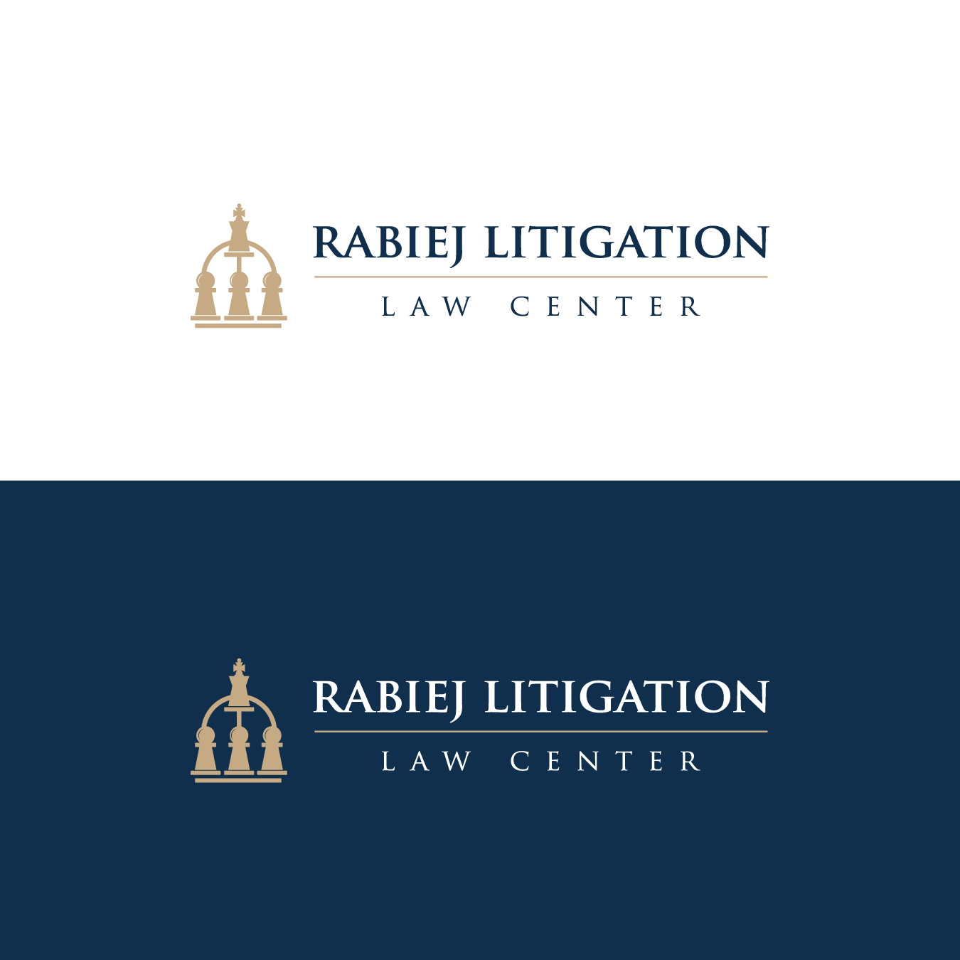

60-Minute Webinar on Meaning of “Relevant” for Discovery Purposes
Rabiej Litigation Law Center and TCDI

The Rabiej Litigation Law Center and TCDI, a leading ediscovery-service provider, will present the first of three 60-minute complimentary webinars that will try to figure out why millions of discovery documents are produced in mass-tort MDLs despite multiple amendments to Rule 26, which were intended to rein in overbroad discovery. The Center has applied for CLE credit for this webinar. You may register at https://www.tcdi.com/rabiej_relevant_webinar_2025/.
The first webinar will be held on Monday, June 23, at 12:00 pm (ET) with:
- John Rabiej (Moderator), Founder of the Rabiej Litigation Law Center
- Hon. Paul Niemeyer, Fourth Circuit Court of Appeals, former chair of the Advisory Committee on Civil Rules
- Hon. Vaughn Walker, Northern District of California (ret.), Vaughn R Walker ADR Law Office
- Paul Doolittle, Poulin | Willey | Anastopoulo, LLC
- Jennifer Greenblatt, Goldman Ismail Tomaselli Brennan & Baum LLP
- Jennifer Andres, TCDI
The first webinar examines different meanings the bench and bar ascribe to the term “relevant” as it is used in Rule 26. Jennifer Goldblatt, Paul Doolittle, and Hon. Vaughn Walker will discuss how they interpret the meaning of “relevant” from their respective perspective. And Jennifer Andres will explain how ediscovery-service providers interpret instructions from their clients for what matter is relevant.
Judge Paul Niemeyer will describe the history of the change of the scope of discovery in 2000 from “relevant to subject matter” to “relevant to any parties’ claims and defenses,” which was intended to narrow discovery.
The second webinar will focus on how plaintiffs manage and report on their review of millions of documents in discovery in a mass-tort MDL so that their lawyers litigating the case can use it.
The third webinar will discuss the 3M Combat Earplug MDL TAR protocol developed by David Buchanan (SeegerWeiss LLP) and Michelle Six (Gunster) who jointly reviewed a random sample of 1,750 documents, classifying them as relevant or not relevant for purposes of training TAR. Having both sides jointly train TAR or another AI system based on information that both sides agree is “relevant” may enhance the confidence in the results and reduce the production of millions of documents in mass-tort MDLs. It also effectively puts into practice the intent of the Rule 26(f) meet-and-confer provision for parties to discuss seriously the nature and basis of their claims and defenses and agree on a shared understanding of relevant matter.
For more information, including bios, materials, and registration click https://rabiejcenter.org/events/.

