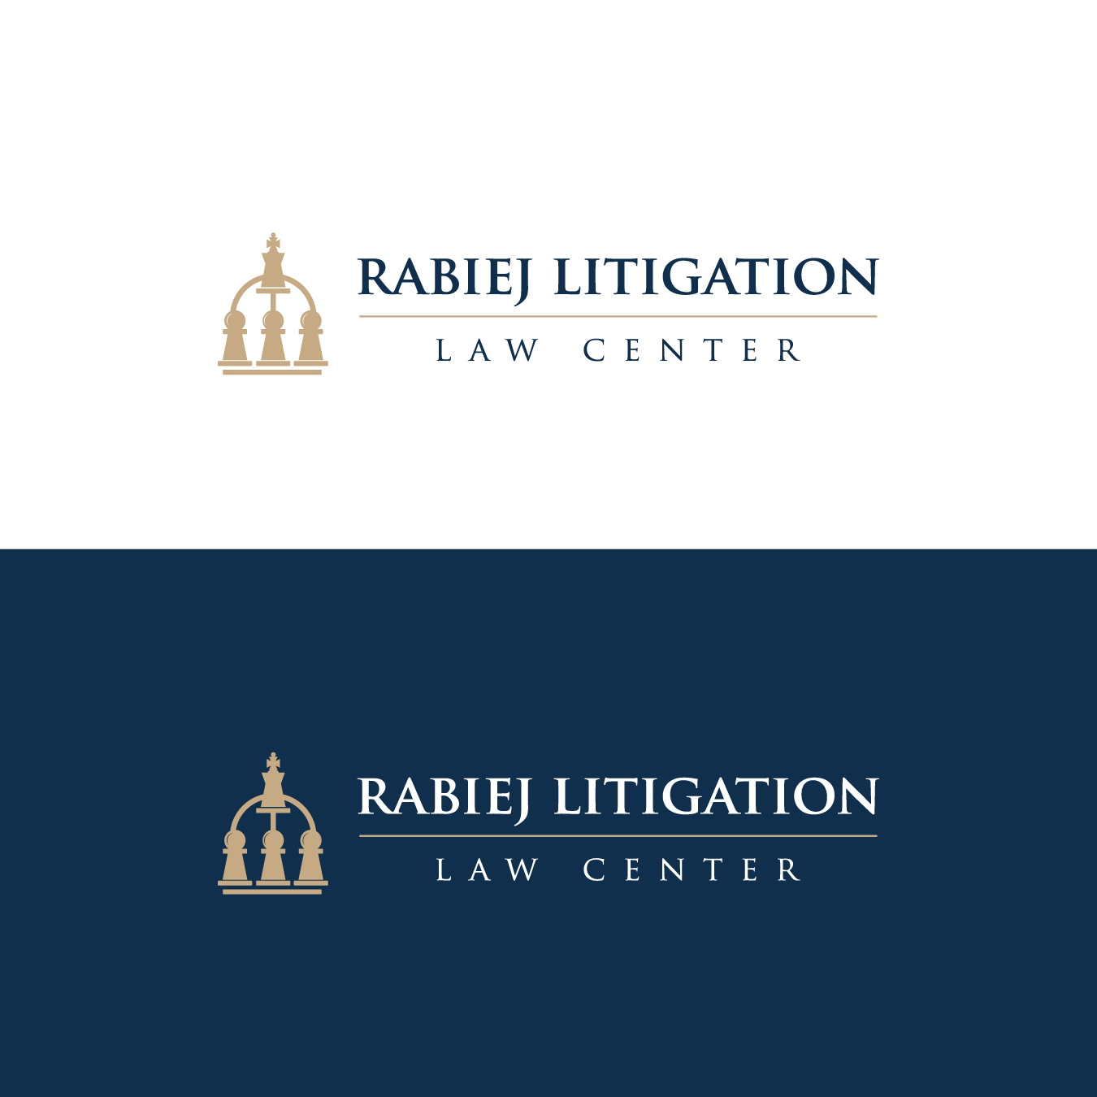

60-Minute eDiscovery Webinar Co-Hosted with TCDI
How Plaintiffs Manage and Review Millions of Documents Produced in Mass-Tort MDLs
Monday, September 22, 2025, at 11:00 a.m. (ET)

BIOS

John Rabiej (Moderator), Founder of the Rabiej Litigation Law Center
John K. Rabiej is the founder of the nonprofit Rabiej Litigation Law Center. He partnered with the George Washington Complex Litigation Center for two years. Mr. Rabiej joined Duke Law in early 2011 after serving one year as the Executive Director/Director of Judicial Outreach for The Sedona Conference. He served as the Deputy Director of the Bolch Judicial Institute for one year and the Director of the Duke Law Center for Judicial Studies for seven years. As the Director of the Judicial Studies Center, Mr. Rabiej oversaw the running of the master’s LLM program for judges, held annual bench-bar conferences, formed lawyer teams that drafted best practices addressing class actions, discovery, and mass-tort MDLs, acquired, managed, and published Judicature for five years, and acquired and managed EDRM for three years.
Previously, Mr. Rabiej was the Chief of the Rules Committee Support Office for 20 years, establishing and heading the office that staffed the six rules committees of the United States Judicial Conference. He has written extensively on ediscovery, including chapter 37A of Moore’s Federal Practice, chapters in Weinstein’s Federal Evidence Manual, co-authored with Judge Lee Rosenthal and Professor David Levi the Federal Civil Procedure Manual, Juris Publisher (2014), and co-authored with former Judge Alex Kozinski the Federal Appellate Procedure Manual, Juris Publisher (2014). Mr. Rabiej was the principal editor of the Guidelines and Best Practices Implementing the 2015 Discovery Amendments Concerning Proportionality (Bolch Judicial Institute, Duke) and Technology Assisted Review (TAR) Guidelines (Bolch Judicial Institute, Duke). He has written the “Director” columns in eight issues of Judicature (2015-2017) and more than 20 articles on ediscovery, which were published in the LexisNexis Emerging Issues series of expert commentaries (2008-2014). He has also written many articles on rules-related issues, including the meaning and purposes of rule amendments and served as principal editor on class action, ediscovery, diversity, securities class actions, and mass-tort MDL best practices at Duke and George Washington Law Schools.
Mr. Rabiej was elected to the American Law Institute in 2005. He received the inaugural “Champion of Class Action Justice” award from the Berkeley Research Group in 2021. He served six years on the North Carolina Chief Justice’s Rules Advisory Commission.

Tim Opsitnick – TCDI, General Counsel
Tim is Executive Vice President and General Counsel, Technology Concepts & Design, Inc. (TCDI). His consulting practice focuses on electronic discovery, cybersecurity, data privacy, and computer forensics. Tim has conducted numerous continuing legal education seminars, written articles, and contributed to publications regarding electronic discovery, cybersecurity, and other technology issues. In addition, he has served as a court-appointed Special Master and as an expert witness. Tim is a past member of the Steering Committee for The Sedona Conference Working Group 1 on Electronic Document Retention and Production, and he is also a member of Sedona Working Groups 6 and 11. He also serves on The Sedona Conference Working Group Series Leadership Council. Tim was an editor of The Sedona Guidelines: Best Practice Guidelines & Commentary for Managing Information & Records in the Electronic Age (Second Edition 2007), a contributor to The Sedona Principles: Best Practice Recommendations and Principles Addressing Electronic Document Production (2004 and Second Edition 2007), a member of the drafting team for The Sedona Principles, Third Edition: Best Practices, Recommendations & Principles for Addressing Electronic Document Production (2017), a WG1 Steering Committee Liaison and Editors-in-Chief, The Sedona Conference Commentary on Legal Holds, Second Edition: The Trigger & The Process (2019), and a WG1 Steering Committee Liaison, The Sedona Conference, Commentary on the Need for Guidance and Uniformity in Filing ESI and Records Under Seal, (2022). Tim is also a member of The Sedona Conference Technology Resource Panel. Tim is a past member of the Advisory Board for Georgetown University Law Center’s Continuing Legal Education for the development of programs for its E-Discovery Institute, and a member of the Advisory Council for EDRM, and a member of the Advisory Council for George Washington Law School, James F. Humphreys Complex Litigation Center.
Honorable David Campbell – District of Arizona (former chair of the Advisory Committee on Civil Rules)
Judge Campbell was nominated to serve as judge of the United States District Court for the District of Arizona by President George W. Bush on March 13, 2003, to a new seat created by 116 Stat. 1758. The United States Senate confirmed him on July 8, 2003 by 92–0 vote. He received his commission on July 15, 2003. Judge Campbell was a member of the Advisory Committee on Federal Rules of Civil Procedure from 2005 to 2011, and chaired the committee from 2011 to 2015, while the Advisory Committee approved important changes to discovery-related rules that ultimately became effective in December 2015. From 2016 to 2020, Judge Campbell chaired the Committee on Rules of Practice and Procedure for the federal courts, which oversees the Civil, Criminal, Appellate, Bankruptcy, and Evidence advisory committees. Judge Campbell currently serves as chair of the federal courts' Committee on International Judicial Relations. He assumed senior status on July 31, 2018.
Judge Campbell has worked with the courts of Botswana, Namibia, South Africa, and other countries on judicial case management.
He is a member of the American Law Institute and a Fellow of the American Bar Foundation.

Alyson Oliver – Oliver Law Group
With a multi-faceted career spanning over 20 years, Alyson Oliver’s experience as a lawyer and managing partner of the Oliver Law Group P.C. has provided a solid foundation for handling intricate litigation. Oliver has thrived over the years on challenging courtroom battles and victories. As a dynamic lawyer, she is a diligent advocate for her clients. Oliver is skilled in all phases of litigation from the preparation and discovery phases through negotiations, hearings, and trials. Oliver has an innate ability to identify and digest legal issues and explain them to clients and juries in non-legal jargon that allows for ease of understanding. Oliver has represented companies, classes, individuals, and the community at large, often in complex matters.
James (Jacksy) Bilsborrow – Weitz Luxenberg, PC
James Bilsborrow is co-chair of our Environmental, Toxic Tort & Consumer Protection group, having joined the firm in 2011.

James represents victims of environmental contamination, toxic exposure, and defective products in complex litigation nationwide. James also represents farmers whose crops have been damaged by defective herbicides and other chemical applications, as well as clients who have developed diseases from their exposure to toxic pesticides, such as people exposed to Roundup.
In the multidistrict litigation concerning formulations of dicamba herbicides, he was appointed by the court to serve as a member of the Plaintiffs’ Executive Committee. In June 2020, the Plaintiffs’ Executive Committee announced a settlement with Monsanto to resolve claims of farmers whose crops were damaged by off-target movement of dicamba herbicides. The settlement is valued at $400 million.

James is also active in many of the firm’s initiatives seeking justice on behalf of property owners and individuals exposed to toxic PFAS chemicals. He was appointed lead class counsel to represent a certified class of property owners and exposed residents in Petersburgh, New York. He successfully defended the class on appeal, obtaining the first appellate court decision in the New York state courts affirming certification of a medical monitoring class. In October 2021, plaintiffs announced a proposed class settlement valued at over $23 million.

In addition, James was appointed co-lead class counsel to represent a proposed class of property owners and individuals exposed to PFOA in Hoosick Falls, New York. In February 2022, the court granted final approval to a partial class settlement valued at $65.25 million. This settlement provided cash payments to owners and renters of property and established a 10-year medical monitoring program that is now ongoing.

Environmental litigation makes up a significant portion of Mr. Bilsborrow’s work. In 2023, he was appointed to the Plaintiffs’ Executive Committee to litigate claims on behalf of the residents of East Palestine, Ohio, following the chemical fires resulting from the derailment of numerous Norfolk Southern train cars on the Ohio-Pennsylvania border. In April 2024, plaintiffs reached a $600 million class settlement with Norfolk Southern to resolve the community’s claims. Mr. Bilsborrow also participated extensively in the multidistrict litigation brought by Weitz & Luxenberg and other firms against BP, the United Kingdom-based petroleum giant responsible for the devastating 2010 Gulf of Mexico oil spill. Mr. Bilsborrow served as the second-chair attorney to our Robin Greenwald, who was a member of the Plaintiffs’ Steering Committee. He worked closely with the Phase One trial team that ultimately secured a judicial finding that BP acted with gross negligence in causing the oil spill. Mr. Bilsborrow also served on the Medical Benefits Settlement team that negotiated a commitment on the part of BP to provide compensation and preventive treatments for Gulf Coast shoreline residents and to workers involved in the spill cleanup.

Paul McVoy – Repario Data, Inc.
Paul is a SVP and Shareholder of Repario, an innovative, client-driven technology company focused on concierge-style litigation support. Paul has been at the forefront of discovery for 30 years, working on matters for both individuals in small cases as well as large, complex litigations. He was an early adopter of technology-assisted review and has been a vocal advocate in support of its use ever since. Paul is an active member of The Sedona Conference Working Group 1 on Electronic Document Retention and Production (WG1) and the editor of The Sedona Conference Glossary, 5th edition. He has also been recognized by Chambers as a Trusted Advisor for Ediscovery since 2018.

