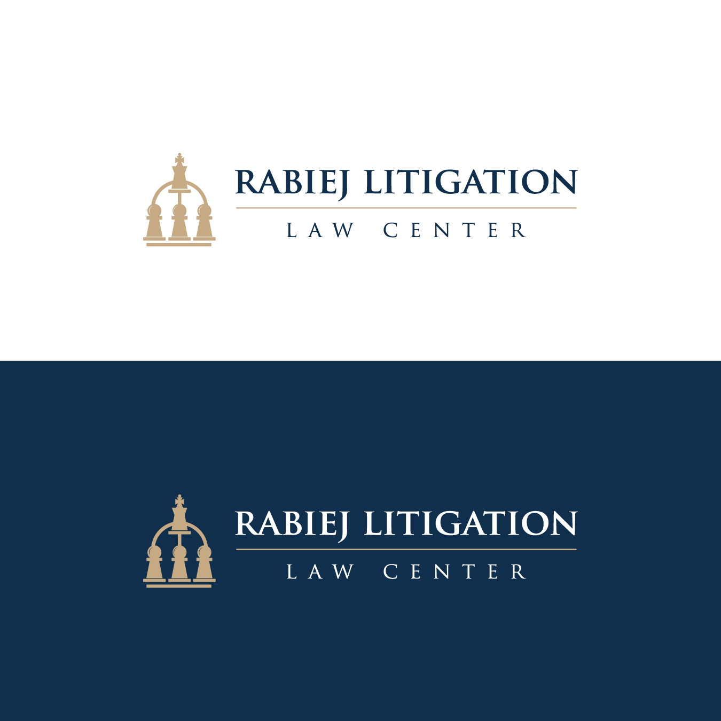
Can Generative AI Deliver on the Promises TAR Failed to Keep in Mass-Tort MDLs
Free Registration for 60-Minute Webinar on March 6

The Rabiej Litigation Law Center is delighted to once again partner with TCDI, a leading eDiscovery-service provider, and hold a complimentary 60-minute webinar on Friday, March 6, at 12:00 pm (ET). The webinar addresses the question “Can generative AI reduce ediscovery production from ten-million documents to just 100,000?”
You may register for free at https://www.tcdi.com/rabiej-mdl-webinar-2026/. The State of New Jersey has approved 1.20 CLE credits for the webinar.
This is the third in a three-part series of webinars. The first two examined the meaning of “relevant” for discovery purposes and the feasibility of joint training of TAR or generative-AI search tools. This webinar will explore the inevitable transition of generative AI into a standard search tool, while examining the critical hurdles likely to slow its widespread implementation, particularly in mass-tort MDLs.
The Center reviewed recent mass-tort MDL filings and found ten that discovery in each produced over a million documents, nine via keywords and one via TAR. These traditional search tools cast a wide net, capturing as many documents as possible based on statistical guesses of their potential value. Over the years, the bench and bar have grown accustomed and seemingly resigned to massive productions -- sometimes exceeding 11 million documents and multiple terabytes of data. This data explosion shows no signs of abating, as new sources and devices add to the discovery burden every day.
Traditional keyword and TAR tools rely on statistical approximations and word-pattern analysis, while generative AI employs active logic to substantively evaluate content and identify critical evidence. Because generative AI can rapidly filter and identify pivotal evidence, the historical reliance on over-production to capture key documents may no longer be justified.
Imagine the value of streamlining a 10-million-document production down to “just” 100,000. The advantages are immediate, far-reaching, and benefit both sides and the court:
- Cost Efficiency: Drastically lower expenses for relevance and privilege reviews.
- Operational Savings: Significant reduction in total production costs.
- Smoother Litigation: A smaller document pool leads to fewer discovery-related conflicts and avoids costly diversions on peripheral or irrelevant issues.
- Better Focus: Attorneys spend less time sifting through insignificant data and more time on consequential tasks.
- Faster Outcomes: Accelerated trial timelines and more rapid case resolutions.
Can AI truly find the 100,000 “useful” documents within a 10-million-document set that are important in resolving the issues? Dr. Aron Ahmadia (Relativity) dives into the current capabilities of generative AI and provides a roadmap for when we can expect this level of ediscovery performance -- be it now, in one year, two years, or beyond.
Steve Goldstein (Altorney) will examine the technical mechanics of generative-AI search tools, while John Rosenthal (Shook Hardy & Bacon) explores the strategic hurdles of developing joint AI prompts and validation protocols and suggests alternatives. Both will also discuss whether generative AI can finally deliver on the promises TAR failed to keep, either now or in the near future, and what pitfalls that limited TAR’s effectiveness need to be overcome for AI to succeed in mass-tort MDLs. Additionally, United States Magistrate Judge Gary Jones (N.D. Florida) will address the work-product implications that arise when courts order joint development of AI prompts and validation processes.
The conversation on the role of generative AI in ediscovery will continue at the Center’s class-action summit at Charleston School of Law on March 12 and the Mass-Tort MDL summit at Northwestern Pritzker School of Law on July 16. Information, including online registration for the summits, is posted at https://rabiejcenter.org/events/.

